**Clock Tower to Kings Road – the front entrance of the Brighton Centre**

**Distance 0.3 mile, approx. 6 minutes**

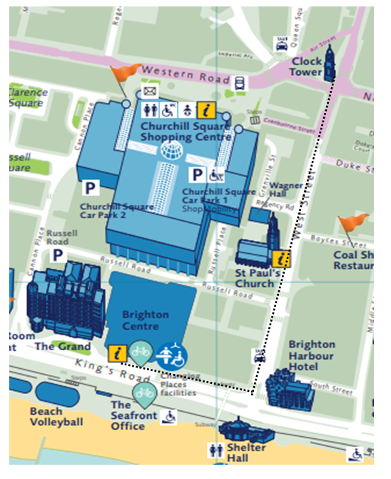

|  |
| --- |
| **From the Clock Tower head towards Waterstones.** |
|  |

|  |
| --- |
| **Cross over at the traffic lights towards Waterstones.** |
|  |
| **At the corner of Waterstones continue down West Street.** |
|  |

|  |
| --- |
|  |
| **Take care when crossing towards Wetherspoons, this is an entrance to Churchill Square car park.** |
|  |

|  |
| --- |
| **Continue down West Street.** |
|  |
| **Cross over at the traffic lights and continue straight ahead towards the sea.**   |
|  |
|  |
| **At the bottom of West Street, turn right onto Kings Road.** |
|  |
|  |

|  |
| --- |
| **Follow the path towards the Brighton Centre.** |
|  |
| **Continue along the front of the Brighton Centre.** |
|  |
|  |

|  |
| --- |
| **Front entrance to the Brighton Centre.** |
|  |